TASK 7.1: DESIGN PARKING SYSTEM
PROGRAM:
class ParkingSystem {
int big;
int medium;
int small;
public ParkingSystem(int big, int medium, int small) {
this.big = big;
this.medium = medium;
this.small = small;
}
public boolean addCar(int carType) {
if (carType == 1) {
if (big > 0) {
big--;
return true;
}
}
else if (carType == 2) {
if (medium > 0) {
medium--;
return true;
}
}
else if (carType == 3) {
if (small > 0) {
small--;
return true;
}
}
return false;
}
}
OUTPUT:
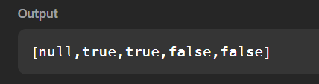

TASK 7.2 : JAVA INSTANCES OF A KEYWORD
PROGRAM:
import java.util.*;
class Student{}
class Rockstar{}
class Hacker{}
public class InstanceOFTutorial{

static String count(ArrayList mylist){
int a = 0, b = 0, c = 0;

for(int i = 0; i < mylist.size(); i++){
Object element = mylist.get(i);

if(element instanceof Student)
a++;

if(element instanceof Rockstar)
b++;

if(element instanceof Hacker)
c++;
}

String ret = Integer.toString(a) + " "
+ Integer.toString(b) + " "
+ Integer.toString(c);

return ret;
}

public static void main(String []args){
ArrayList mylist = new ArrayList();
Scanner sc = new Scanner(System.in);

int t = sc.nextInt();

for(int i = 0; i < t; i++){
String s = sc.next();

if(s.equals("Student"))
mylist.add(new Student());

if(s.equals("Rockstar"))
mylist.add(new Rockstar());

if(s.equals("Hacker"))
mylist.add(new Hacker());
}

System.out.println(count(mylist));
}
}import java.util.*;

class Student{}
class Rockstar{}
class Hacker{}

public class InstanceOFTutorial{

static String count(ArrayList mylist){
int a = 0, b = 0, c = 0;

for(int i = 0; i < mylist.size(); i++){
Object element = mylist.get(i);

if(element instanceof Student)
a++;

if(element instanceof Rockstar)
b++;

if(element instanceof Hacker)
c++;
}

String ret = Integer.toString(a) + " "
+ Integer.toString(b) + " "
+ Integer.toString(c);

return ret;
}

public static void main(String []args){
ArrayList mylist = new ArrayList();
Scanner sc = new Scanner(System.in);

int t = sc.nextInt();

for(int i = 0; i < t; i++){
String s = sc.next();

if(s.equals("Student"))
mylist.add(new Student());

if(s.equals("Rockstar"))
mylist.add(new Rockstar());

if(s.equals("Hacker"))
mylist.add(new Hacker());
}

System.out.println(count(mylist));
}
}
OUTPUT:
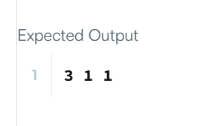

TASK 7.3 : DESIGN UNDERGROUND SYSTEM
PROGRAM:
import java.util.*;
class UndergroundSystem {
HashMap<Integer, CheckIn> checkIns;
HashMap<String, Route> routes;
class CheckIn {
String station;
int time;
CheckIn(String station, int time) {
this.station = station;
this.time = time;
}
}
class Route {
int totalTime;
int count;
Route(int totalTime, int count) {
this.totalTime = totalTime;
this.count = count;
}
}
public UndergroundSystem() {
checkIns = new HashMap<>();
routes = new HashMap<>();
}
public void checkIn(int id, String stationName, int t) {
checkIns.put(id, new CheckIn(stationName, t));
}

public void checkOut(int id, String stationName, int t) {
CheckIn c = checkIns.get(id);
String key = c.station + "#" + stationName;
int travelTime = t - c.time;
if (routes.containsKey(key)) {
Route r = routes.get(key);
r.totalTime += travelTime;
r.count++;
} else {
routes.put(key, new Route(travelTime, 1));
}
checkIns.remove(id);
}
public double getAverageTime(String startStation, String endStation) {
String key = startStation + "#" + endStation;
Route r = routes.get(key);
return (double) r.totalTime / r.count;
}
}
OUTPUT:
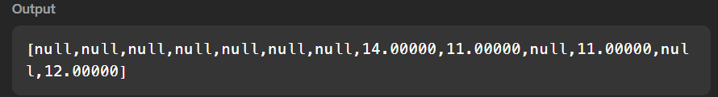

TASK 7.4 : DESIGN BROWSER HISTORY
PROGRAM:
class BrowserHistory {
class Node {
String url;
Node prev;
Node next;
Node(String url) {
this.url = url;
}
}
Node current;
public BrowserHistory(String homepage) {
current = new Node(homepage);
}
public void visit(String url) {
Node newNode = new Node(url);
current.next = newNode;
newNode.prev = current;
current = newNode;
}
public String back(int steps) {
while (steps > 0 && current.prev != null) {
current = current.prev;
steps--;
}
return current.url;
}
public String forward(int steps) {
while (steps > 0 && current.next != null) {
current = current.next;
steps--;
}
return current.url;
}
}
OUTPUT:
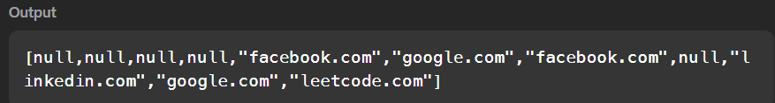

TASK 7.5 : HASHSET
PROGRAM:
class MyHashSet {
boolean[] set;
public MyHashSet() {
set = new boolean[1000001];
}
public void add(int key) {
set[key] = true;
}
public void remove(int key) {
set[key] = false;
}
public boolean contains(int key) {
return set[key];
}
}
OUTPUT:
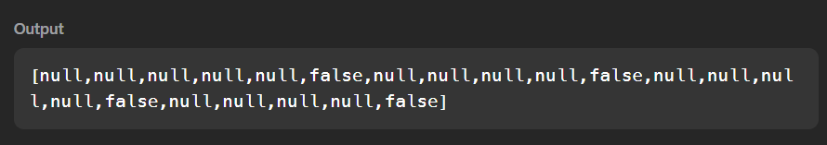

TASK 7.6 : GRADING STUDENTS
PROGRAM:
import java.io.*;
import java.util.*;
import java.util.stream.*;
import static java.util.stream.Collectors.toList;
class Result {
public static List<Integer> gradingStudents(List<Integer> grades) {
for (int i = 0; i < grades.size(); i++) {
int grade = grades.get(i);
if (grade >= 38) {
int next = ((grade / 5) + 1) * 5;
if (next - grade < 3) {
grades.set(i, next);
}
}
}
return grades;
}
}
public class Solution {
public static void main(String[] args) throws IOException {
BufferedReader bufferedReader =
new BufferedReader(new InputStreamReader(System.in));
BufferedWriter bufferedWriter =
new BufferedWriter(new FileWriter(System.getenv("OUTPUT_PATH")));
int gradesCount =
Integer.parseInt(bufferedReader.readLine().trim());
List<Integer> grades = IntStream.range(0, gradesCount)
.mapToObj(i -> {
try {
return bufferedReader.readLine().replaceAll("\\s+$", "");
} catch (IOException ex) {
throw new RuntimeException(ex);
}
})
.map(Integer::parseInt)
.collect(toList());
List<Integer> result = Result.gradingStudents(grades);
bufferedWriter.write(
result.stream()
.map(Object::toString)
.collect(Collectors.joining("\n"))
+ "\n"
);
bufferedReader.close();
bufferedWriter.close();
}
}
OUTPUT:
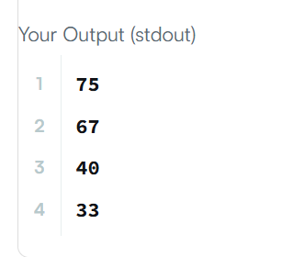

TASK 7.7 : JAVA INHERITANCE 1
PROGRAM:
import java.io.*;
import java.util.*;
import java.text.*;
import java.math.*;
import java.util.regex.*;
class Animal {
void walk() {
System.out.println("I am walking");
}
}
class Bird extends Animal {
void fly() {
System.out.println("I am flying");
}
void sing() {
System.out.println("I am singing");
}
}
public class Solution {
public static void main(String[] args) {
Bird bird = new Bird();
bird.walk();
bird.fly();
bird.sing();
}
}

OUTPUT:
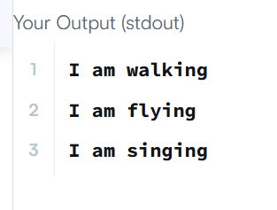

TASK 7. 8: JAVA INHERITANCE 2
PROGRAM:
import java.io.*;
import java.util.*;
class Arithmetic {
int add(int a, int b) {
return a + b;
}
}
class Adder extends Arithmetic {
}
public class Solution {
public static void main(String[] args) {
Adder adder = new Adder();
System.out.println("My superclass is: "
+ adder.getClass().getSuperclass().getName());
System.out.println(adder.add(42, 13) + " "
+ adder.add(10, 10) + " "
+ adder.add(5, 15));
}
}
OUTPUT:
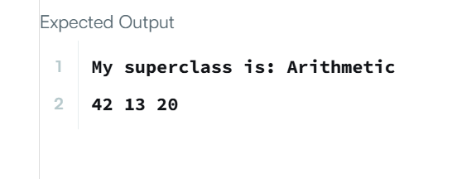

TASK 7.9 : JAVA GENERICS
PROGRAM:
import java.io.*;
import java.util.*;
public class Solution {
public static <T> void printArray(T[] array) {
for (T element : array) {
System.out.println(element);
}
}
public static void main(String[] args) {
Integer[] intArray = {1, 2, 3};
String[] stringArray = {"Hello", "World"};
printArray(intArray);
printArray(stringArray);
}
}
OUTPUT:
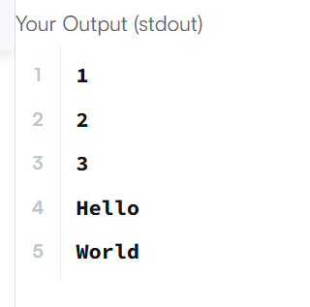

TASK 7.10: THRONE INHERITANCE
PROGRAM:
import java.util.*;
class ThroneInheritance {
String king;
Map<String, List<String>> children;
Set<String> dead;
public ThroneInheritance(String kingName) {
king = kingName;
children = new HashMap<>();
dead = new HashSet<>();
}
public void birth(String parentName, String childName) {
children.putIfAbsent(parentName, new ArrayList<>());
children.get(parentName).add(childName);
}
public void death(String name) {
dead.add(name);
}
public List<String> getInheritanceOrder() {
List<String> result = new ArrayList<>();
dfs(king, result);
return result;
}
private void dfs(String person, List<String> result) {
if (!dead.contains(person)) {
result.add(person);
}
if (children.containsKey(person)) {
for (String child : children.get(person)) {
dfs(child, result);
}
}
}
}
OUTPUT:
